**CSE 573: Computer Vision and Image Processing**

**Homework 1**

Building a scene recognition system.

* **Ketan Shah (Person no. 50247131)**

**Q 1.0** What properties do each of the ﬁlter functions (see Figure 3) pick up? You should group the ﬁlters into broad categories (i.e., all the Gaussians). Answer in your write-up.

**Ans**: The first 5 filters in the filter bank are the Gaussian filters at different scales. What these filters do is they smoothen out the image and divide it into similar parts. Similar parts meaning if you notice the filter response from these filters the regions will only change color if there if a sudden change. Like for example paintings hanging on a white wall. The whole area of the white wall was a single region and the paintings were depicted by a different color. Another example very bright light entering a room. The area where the light brightens it will be a single region and outside that will be denoted by a different value. The scale change just blurs the image more and further blends the regions. More we increase the scale the lesser details are captured but the regions blend out more removing sudden changes to a greater extent and grouping more things together.

The next 5 filters were Laplacian of Gaussian filters. These filters reveal the edge of all the objects in the image. It sorts of gives everything an outline. The higher we take the scale the blurrier and thick the outline becomes.

The next 5 filters we have are x-derivative of Gaussian. We know that taking derivative of the image on the x-axis reveals vertical line changes and highlights the vertical lines in the image. So x-derivative highlights the vertical areas within the outlines.

The last 5 filters we have are y-derivative of Gaussian and highlight the horizontal area of the image between the edges, similar to the previous set of filters but in the horizontal manner.

**Q 1.1** Please find below the collage of filter responses following their original image after applying the filter bank to the image:

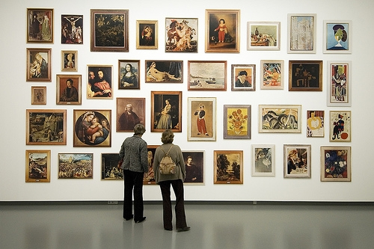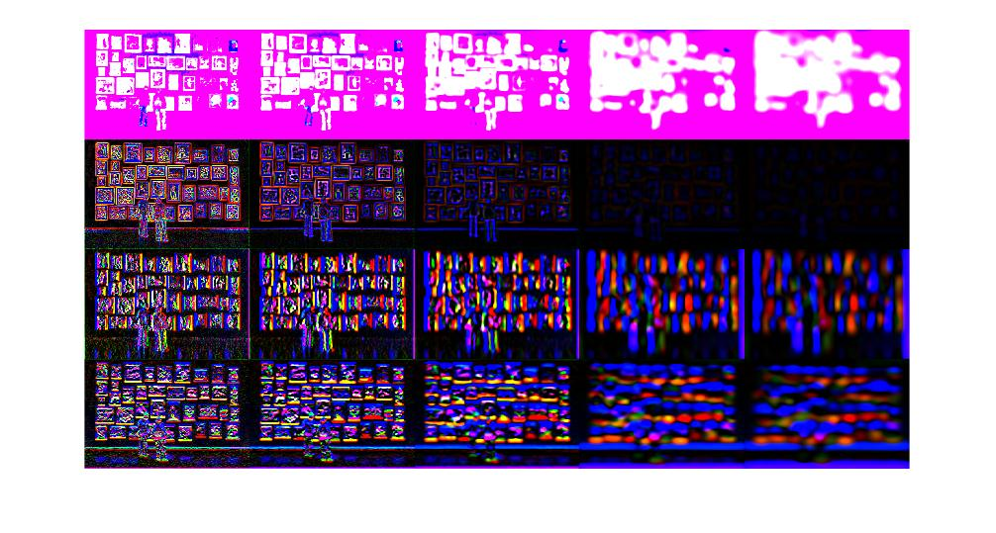

**Q 1.3** - Please find the visualizations of 3 sample images taken from different categories:

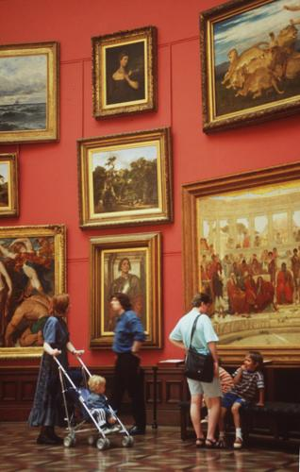

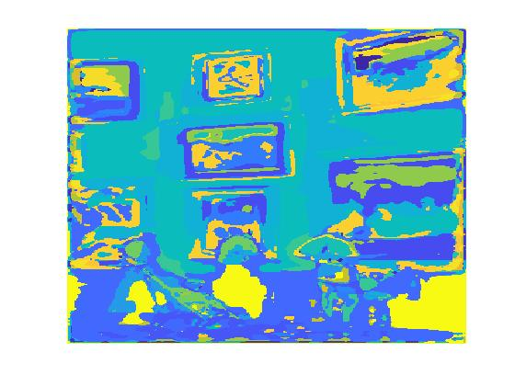

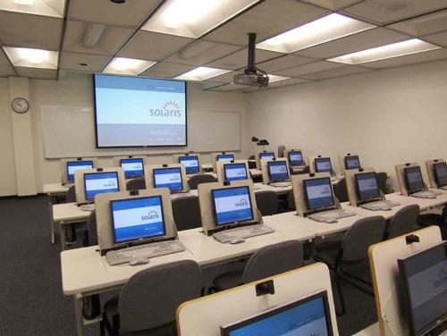 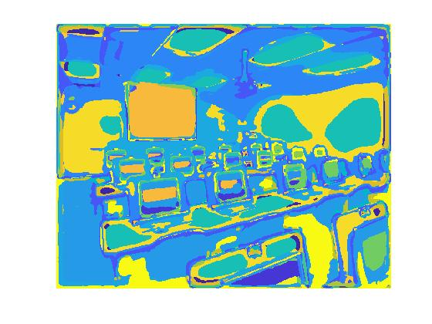

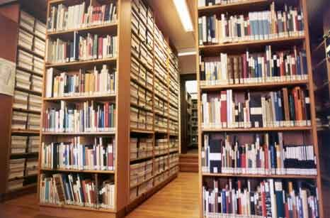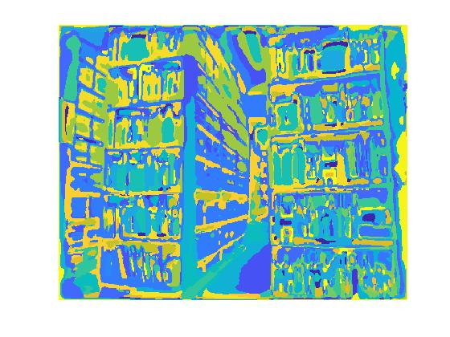

The visualizations reveal some interesting data. Similar looking objects are falling in the same group if you notice. This is because of the different filters we applied. For example, the library picture above. Also interesting fact is the areas which have slightly different brightness and light settings fall into different group even though they are similar objects. They are in same group within themselves.

**Q 2.5:** The accuracy for the program is **54.38 percent.** I’ve included the confusion matrix in the files.

Please see the visualization of the confusion matrix below. The numbering is as per the mapping provided.

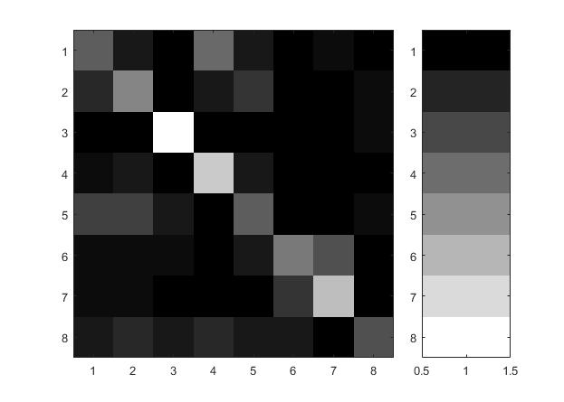

So in the above visualization the lighter color means higher accuracy. So colors tending towards white mean more samples of the particular category were identified correctly. Here we should only notice the diagonals for accurate samples. From the above visualization you can see that the category ‘garden’ was the most accurately identified. Performance in categories ‘ocean’ and ‘ice skating’ were fairly accurate as well. Following them were categories ‘Computer room’ and ‘mountain’ of which around 50 % samples matches. The lowest performance were ‘art gallery’ it seems from studying the matrix.

**Q 2.6 Failed Cases:**

From the confusion matrix one can notice that many of the images belonging to the library category were identified as ‘art gallery’ or ‘computer room’. This might be because all these 3 categories display similar characteristics on some level. Each one has repetitions of rectangular objects over space. This is highly intuitive but the data supports the thought. Also I noticed one more case where failure was high if we chose images of green colored mountains. It almost always was identified as a garden image.

From the matrix above it also appears that many art gallery images were identified as ice_skating pictures. The reason for this could be the appearance of lighter colors over a high area. Art galleries having white walls and ice skating rinks having white ground for playing. Some times the tennis court images were also misinterpreted as ice skating rinks maybe because of similarity in the layout.